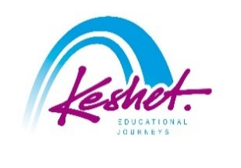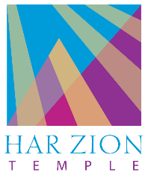

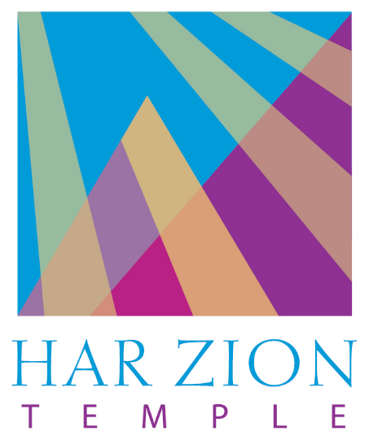

**A Great Miracle!**

**Har Zion's Hanukkah trip to Israel!**

Parallel itineraries: “Choose your own adventure”

Led by Rabbi Seth Haaz and Norman Einhorn

*December 22, 2024-January 1, 2025*

updatedFebruary 25

|  |  |
| --- | --- |
| **Sunday, December 22:** | ***here we come!*** |

* Depart from Newark Airport – El Al flight 26 departing at 9:00pm

|  |  |
| --- | --- |
| **Monday, December 23:** | ***Bruchim Habaim – welcome to Israel!*** |

* Land in Tel Aviv at 2:20pm – meet and greet service
* Meet your guide, pack up the bus and travel to Tel Aviv
* Start your trip where Israel got its official start – outside Independence Hall – with a **welcome to Israel ceremony**
* Check into the hotel, followed by dinner

***Overnight:*** *Carlton Hotel, Tel Aviv*

|  |  |  |
| --- | --- | --- |
| **Tuesday, December 24:** | ***startup nation*** | |
|  |  | |
| **Family Trip**   * Enter the subterranean munitions factory where Jews produced bullets literally under the noses of the ruling British leading up to the War of Independence at the **Ayalon Institute** * Visit the **Weizmann Institute of Technology Visitors Center** for a quick look at some of the projects in the Israeli startup world * Peruse the local crafts, enjoy the street performers and taste some of the street food at the renowned **Nahalat Binyamin Arts and Crafts Fair** and the adjacent **Carmel Market** * At **Save a Child’s Heart**, learn about this institution which brings children from Africa and across the Middle East to Israel for life-saving heart surgery; then interact with the children as the prepare for or recover from their surgery | | **Returnees**   * **Dr. Rachel Korazim** will demonstrate how Zionist poets and songwriters have depicted the “real” Israeli – the so-called sabra – and look at their advice to immigrants to cast off the old ways. We’ll see that, nonetheless, the process of becoming Israeli is as complicated in literature as it is in real life. Dr. Korazim is a renowned educator who uses song, poetry, and literature to shine a light on Israeli life and society * **Jaffa Stories and Coffee**: You’re warmly invited into the home of to hear about her life as a Christian Arab in Jaffa. Over coffee brewed **Doris Hiffawi** by her family and Arabic sweets, she’ll talk about whether the area’s Jewish, Muslim, and Christian population mix or merely make do. We’ll also find out how female entrepreneurs like Doris are bringing change to this socioeconomically deprived neighborhood. * Peruse the local crafts, enjoy the street performers and taste some of the street food at the renowned **Nahalat Binyamin Arts and Crafts Fair** and the adjacent **Carmel Market** * At **Save a Child’s Heart**, learn about this institution which brings children from Africa and across the Middle East to Israel for life-saving heart surgery; then interact with the children as the prepare for or recover from their surgery | |

* Unique culinary experience at dinner in the total dark at the **Blackout Restaurant** of the Na Lagaat (please touch) Center for the deaf and blind

***Overnight:*** *Carlton Hotel, Tel Aviv*

|  |  |  |
| --- | --- | --- |
| **Wednesday, December 25:** | ***going down*** | |
|  |  | |
| **Family Trip**   * Participate in an **actual archaeological dig** at the Beit Guvrin National Park * Hear the tragic stories from October 7th and **support the residents of the kibbutzim and villages** affected during this terrible time * Time permitting, visit **Sde Boker** and the grave of Israel’s first prime minister – David Ben Gurion – and explore his vision to make the desert bloom | | **Returnees**   * Hear the tragic stories from October 7th and **support the residents of the kibbutzim and villages** affected during this terrible time * Experience one man’s dream of making the desert bloom, on an agricultural tasting tour of the **Salad Trail** in the Gaza Envelope * Time permitting, visit **Sde Boker** and the grave of Israel’s first prime minister – David Ben Gurion – and explore his vision to make the desert bloom | |

* Check into the hotel
* Light candles for the first night of Channukah, followed by dinner

***Overnight:*** *Ramon Suites Hotel, Mitzpe Ramon*

|  |  |
| --- | --- |
| **Thursday, December 26:** | ***the crater and the creator*** |

* Optional early-morning hike to watch the sunrise over the **Ramon Crater**

|  |  |
| --- | --- |
| **Family Trip**   * Take a long walk off a short cliff – **repelling** into the Ramon Crater * Take **jeeps** off road into the Ramon Crater and explore this geological phenomenon * At the **Mitzpe Ramon Visitors Center**, learn about the formation of the crater and about Israel’s first astronaut in space, who took his name from the crater | **Returnees**   * Take **jeeps** off road into the Ramon Crater and explore this geological phenomenon * At the **Mitzpe Ramon Visitors Center**, learn about the formation of the crater and about Israel’s first astronaut in space, who took his name from the crater * Get a different feel for the desert through **Desert Archery** |

* Dinner in the hotel
* Light the Channukah candles for the second night
* In the evening, go **star gazing** in one of the world’s best stargazing parks using some of the best portable telescopes in Israel

***Overnight:*** *Ramon Suites Hotel, Mitzpe Ramon*

|  |  |  |  |
| --- | --- | --- | --- |
| **Friday, December 27:** | ***the desert for dessert*** | | |
|  |  | | |
| **Family Trip**   * Get a different feel for the desert through **Desert Archery** | | **Returnees**   * Meet with **Ethiopian-born Rabbi Sharon Shalom** and hear his incredible journey “home” to Israel |

* Travel to Jerusalem
* At the **Haas Promenade**, say the *shehechiyanu* blessing and drink a l’chaim; then beginthe exploration of the Jewish love affair with Jerusalem; remember the Biblical accounts of the Binding of Isaac, associated with this spot
* Check into the hotel and prepare for shabbat
* Light the Channukah candles for the third night and then Shabbat candles
* In the evening, participate in a group **Kabbalat Shabbat** at the pluralistic section of the **Western Wall**; then join the thousands of Israelis and Jews from around the world as they bring in **Shabbat at the Western Wall**
* Shabbat dinner in the hotel

***Overnight:*** *Mamilla Hotel, Jerusalem*

|  |  |
| --- | --- |
| **Saturday, December 28:** | ***Shabbat Shalom*** |

* Shabbat services in local synagogues
* **Study session** with Rabbi Haaz
* Hear the incredible story of **Palestinian Issam Saad**, a former Gazan who has been on the Hamas’s Most Wanted list after starting an Israeli-Palestinian dialogue camp for Israeli and Palestinian youth.
* Shabbat lunch in the hotel
* In the afternoon, walk through the Old City to the **Church of the Holy Sepulcher** – one of the holiest places on earth for most Christians – and understand the importance to Jerusalem to all monotheistic religions
* In the neighborhood of Nachlaot, join local musician Rika Razel (of the famous Razel siblings) for a musical **havdallah** and Channukah candle-lighting for the fourth night; then tour the neighborhood to see the plethora of chanukiyot lit
* Free evening to explore Jerusalem’s nightlife

***Overnight:*** *Mamilla Hotel, Jerusalem*

|  |  |
| --- | --- |
| **Sunday, December 29:** | ***This year in jerusalem!*** |

|  |  |
| --- | --- |
| **Family Trip**   * In the **City of David**, site of biblical Jerusalem; see the probable foundations of King David's palace; Bible in hand, understand how Jerusalem became the venue for the development of classic Jewish values and our national identity; with your flashlights and water shoes, exit via the **water tunnel dug by King Hezekiah** 2,700 years ago in order to save the city from the Assyrians (or take the dry tunnel on this winter day) * Lunch and shopping time in the Jewish Quarter and the Roman/Byzantine Cardo * Say a prayer at the Ezrat Yisrael of the **Western Wall** * See how incredible King Herod’s Temple Project must have been at the **Western Wall Tunnels** | **Returnees**   * Political topography tour with **Dani Tirza**, former member of the Oslo Accords committee in the 1990s and the man who planned and implemented the security barrier; hear the reasoning behind the initiative and – at the barrier – understand the reasoning behind its placement and its effectiveness * Drive through the town of **Efrat** and meet with a local resident to understand what a “settlement” really is * Lunch with Jewish and Palestinian activists * In the Palestinian town of Hussan, participate in a **Cleaning the Hatred** project; then meet with local Jewish and Palestinian residents to hear their thoughts on coexistence * Processing session |

* Head over to the vibrant **Machane Yehuda Shuk** for a **culinary tour** to taste some of the incredible Israeli street food; then participate in a **cooking seminar**
* Light Channukah Candles for the fifth night

***Overnight:*** *Mamilla Hotel, Jerusalem*

|  |  |
| --- | --- |
| **Monday, December 30:** | ***what price freedom?*** |

|  |  |
| --- | --- |
| **Family Trip**   * Hike up (or, for those who want – take the cable car) **Masada,** the desert fortress, and hear one of the most dramatic stories in Jewish history * Hike the **Ein Gedi waterfall trail** * **Float in the Dead Sea** * **Ride camels** to Abraham’s (of Biblical fame) tent; hear his stories and enjoy his renowned hospitality over dinner at **Genesis Land** | **Returnees**   * Walk along the streets of the Old City for a behind the scenes **look** at the various **communities in Jerusalem** including:   ▪ A meeting with an **Armenian Ceramic Artist** and a visit to his workshop, followed by a short tour of the Armenian Quarter, the smallest of the four quarters with the smallest number of residents.  ▪ A visit to **Christ Church**, the oldest Protestant Church in the Middle East, which looks exactly like a synagogue.  ▪ A visit to the **Austrian Hospice**, a European enclave in the heart of the Old City, known for its breath-taking views (and delicious strudel) from the rooftop terrace.  ▪ There will also be time to see the bargains and the bargaining in the **Old City Souq** (market) in the Christian quarter.   * See the most recent archaeological finds of the **Western Wall Tunnels** on the **Behind-the-Scenes** tour * Experience the complexity of inter-religious relations on **Mount Zion**. We’ll first visit the **Upper Room**. It is venerated by Christians as the location of Jesus’ Last Supper but was, for a period, converted into a mosque. In a room directly below, Jews pray at the place believed to be **King David’s Tomb.** |

***Overnight:*** *Mamilla Hotel, Jerusalem*

|  |  |
| --- | --- |
| **Tuesday, December 31:** | ***From holocaust to redemption*** |

* Optional: celebrate **Rosh Chodesh** with a prayer service at the **Kotel (Western Wall)**. We’ll join **Women of the Wall**, leaders in the struggle for religious freedom in Israel, in welcoming the arrival of the new month with a service of joy and togetherness.

|  |  |
| --- | --- |
| **Family Trip**   * Learn and remember at the **Yad Vashem Holocaust Museum;** young children to the Biblical Zoo or the Bloomfield Science Museum (depending on weather) * Take the Connection Path up to the **Mt. Herzl National Military Cemetery**; see the graves and hear the stories of the Leaders of the Nation and of the soldiers who fell defending it, including Philadelphia native Michael Levin | **Returnees**   * **The Art of Tikkun Olam**: Meet elderly, often impoverished, immigrants who are finding a sense of purpose and creating beautiful artwork at Yad LaKashish (Lifeline for the Elderly). We’ll hear personal stories and see the aging artisans in action, talk with those running this inspirational organization, and check out the fabulous gift shop that supports this endeavor. * Tour the lesser-known sections of **Yad Vashem**, including the sculpture garden and the Valley of the Communities * In the **Mt. Herzl National Military Cemetery**, see the graves and hear the stories of the Leaders of the Nation and of the soldiers who fell defending it, including Philadelphia native Michael Levin |

* **Final discussion**
* **Farewell dinner**
* Return to the airport for your flight home

|  |  |
| --- | --- |
| **Wednesday, January 1:** | ***Next year in Jerusalem!*** |

* Depart – El Al flight 27 departing at 1:00am
* Land in Newark at 6:00am
* Start planning your next trip to Israel!
* Listed activities and speakers are subject to confirmation.
* Program will be staffed by a Keshet Israel Tour Educator.
* There will be parallel educational programming for adults and youth throughout the trip to allow for age-appropriate learning.
* All breakfasts plus underlined meals are included in the package price.
* This itinerary is proprietary to Keshet and is intended for the promotion of and to inform those considering joining this Keshet trip. It is not to be transmitted to any other party without prior authorization from Keshet

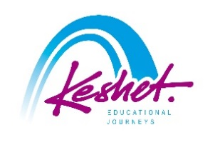

**Keshet Educational Journeys**

PO Box 52236 Jerusalem 9152102 Israel

Phone: 972-2-671-3518 | Fax: 972-2-671-3624

keshet@keshetisrael.co.il | www.keshetisrael.co.il