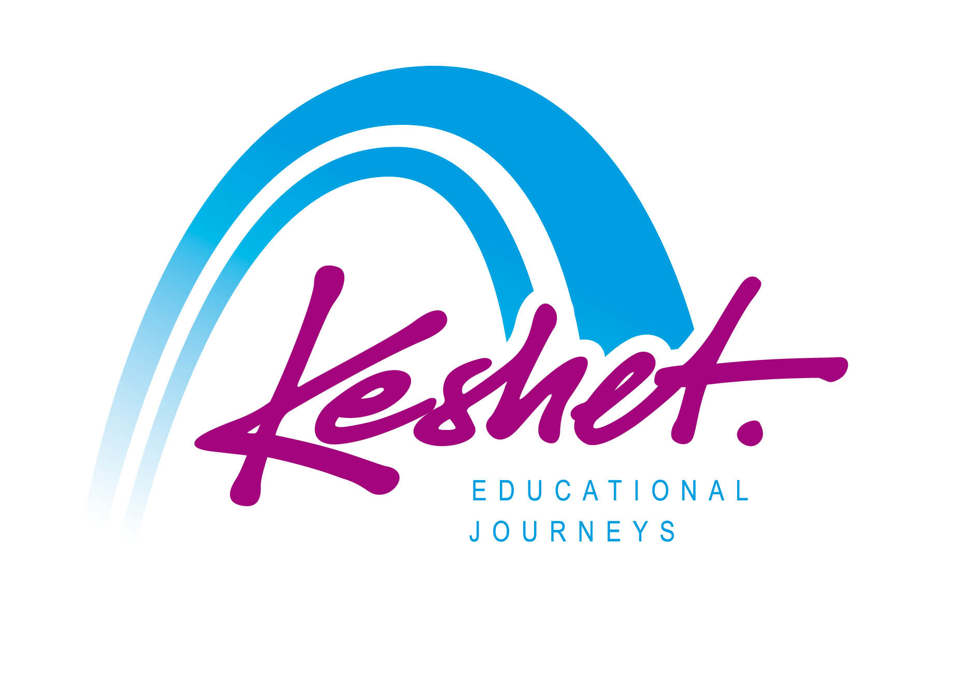

**Jewish Heritage Tour to Poland**

September 1 - 9, 2024

*(Itinerary - Subject to Change)*

_____________________________________________________________________________________________

**Sunday September 1**

* Check in at our hotel in Warsaw from 3:00 PM
* Opening Group Dinner

**Overnight:** WestinHotel, *Warsaw*

____________________________________________________________________________________________

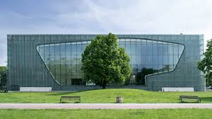**Monday September 2**

* Breakfast at the hotel
* Docent tour at Warsaw's **Polin** **Museum of the History of Polish Jews.** The museum presents an overview of 1,000 years of Jewish history in Poland. The 3.3 million Jews of Poland made up about 10% of the pre-World War II population of Poland.
* Lunch
* At Warsaw’s **Genscha Street Cemetery,** consider “The Life that Was”**.**

Dating to 1799, it has over 200,000 graves and tells the story of Warsaw’s Jewish Community.

* Visit the **Nozyk Synagogue**, *the only synagogue in Warsaw to survive WWII*
* Guided walking tour of **Warsaw’s beautifully restored Old Town**
* Evening and dinner on your own in Warsaw

**Overnight:** Westin Hotel, *Warsaw*

_____________________________________________________________________________________

**Tuesday September 3**

* Breakfast at the hotel; pack bus and depart
* 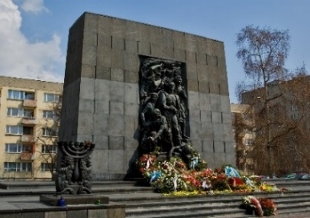Explore what had been the area of **Warsaw Ghetto** including UmshlagPlatz, Mila 18, and the Rappaport Memorial. *The 340,000 Jews of Warsaw made up about 1/3 of the city's population in 1939.*
* Depart Warsaw to Treblinka; packed lunch enroute
* Stand in solemn memory at the site of the **Treblinka** Death Camp where over 870,000 Jews were murdered by the Nazis, including most of the Jews of Warsaw
* Continue to **Lublin**
* Visit the restored **Chachmei Lublin Yeshiva** for a window into pre-war Jewish life (The Yeshiva - now the Ilan Hotel- was founded in 1930 by Rabbi Meir Shapiro to bring a new dignity and status to the study of Torah. Rabbi Shapiro also founded the Daf Yomi movement)
* Dinner
* Check-in at our hotel

**Overnight:** Grand LubliniankaHotel, *Lublin*

_____________________________________________________________________________________

**Wednesday September 4**

* Breakfast at the hotel; pack bus and depart
* Learn and remember at the site of the **Majdanek Concentration Camp**
* 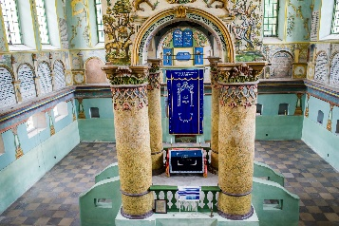Packed Lunch
* Visit the beautifully restored 18th century synagogue in **Lancut,** home to 2,000 Jews before the Shoa
* Continue to Krakow for check-in at our hotel. *Prior to the Shoah, there were 60,000 Jews in Krakow who made up 25% of the city’s population*
* Dinner on your own

**Overnight:** Holiday Inn City Center,*Krakow*

**Thursday September 5**

* Breakfast at the hotel
* Explore the **Kazmierz Old Jewish Quarter** of Krakow exploring ***“The World That Was”.*** Sites include: Ramah Synagogue/Cemetery, Kupah and Temple Synagogues.
* Visit the **Krakow Jewish Community Center** and learn about Jewish life in Krakow today
* Lunch on your own
* See the **Nazi era Krakow Ghetto** including a section of the **Ghetto Wall** and the **Schindler Factory Gates**
* Visit and tour the magnificent medieval **Krakow Old Town Square**
* Dinner and evening on your own

**Overnight:** Holiday Inn City Center,*Krakow*

**Friday September 6**

* Breakfast at the hotel
* 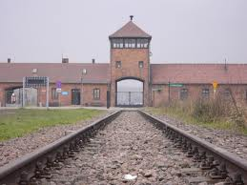Head to the **Auschwitz**-**Birkenau** Polish State **Museum & Memorial**
* Start at the site of the **Auschwitz I Concentration Camp.** Visit the barracks, museum exhibits and gas chamber.
* Packed Lunch
* Continue to the site of the **Auschwitz II Birkenau Death Camp** where over 1,000,000 Jews were murdered.
* Return to Krakow – Shabbat Candle lighting 6:54 PM
* Option to join the local **Jewish community** for **Kabbalat Shabbat Services**
* **Shabbat Dinner** at the Krakow Jewish Community Center

**Overnight:** Holiday Inn City Center, *Krakow*

_____________________________________________________________________________________

**Shabbat September 7 Shabbat Shalom**

* 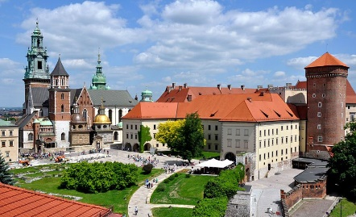Breakfast at the hotel
* Morning: Optional Shabbat Synagogue services or explore the city on your own
* Lunch on your own *(Kosher Shabbat Lunch can be pre-ordered at additional cost)*
* Guided walking tour at the **Wawel Royal Castle,** once the residence of the **Kings of Poland** *and today the symbol of Polish statehood and one of the Poland’s premier art museums.*
* Evening and dinner on your own *(Havdallah 7:53 PM)*

**Overnight:** Holiday Inn City Center, *Krakow*

**Sunday September 8**

* Breakfast at the hotel; pack bus and depart
* 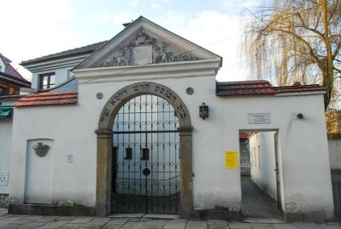Guided tour at the **Galicia Jewish Museum**
* Head underground to explore at the **Wieliczka Salt Mines**, a UNESCO World Heritage Site
* Lunch on your own in the Krakow Kazimierz Old Jewish Quarter
* Depart Krakow to Warsaw
* Check-in at our hotel
* Closing Dinner and Trip Processing session

**Overnight:** WestinHotel, *Warsaw*

*______________________________________________________________________________*

**Monday September 9**

* Breakfast at the hotel; checkout by 11 AM
* Closing session with a **local Jewish community leader:** *The Jewish Community of Poland Today*
* One group bus transfer to Warsaw Chopin Airport timed to the departure time of most of the group
* Listed activities and speakers are subject to confirmation.
* Underlined meals are included in the package price; all provided lunches and dinners will be kosher



**Keshet Educational Journeys**

PO Box 8540 Jerusalem 91084 Israel

Phone: 972-2-671-3518 | Fax: 972-2-671-3624

keshet@keshetisrael.co.il | www.keshetisrael.co.il