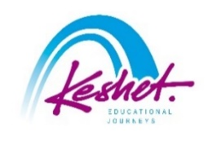

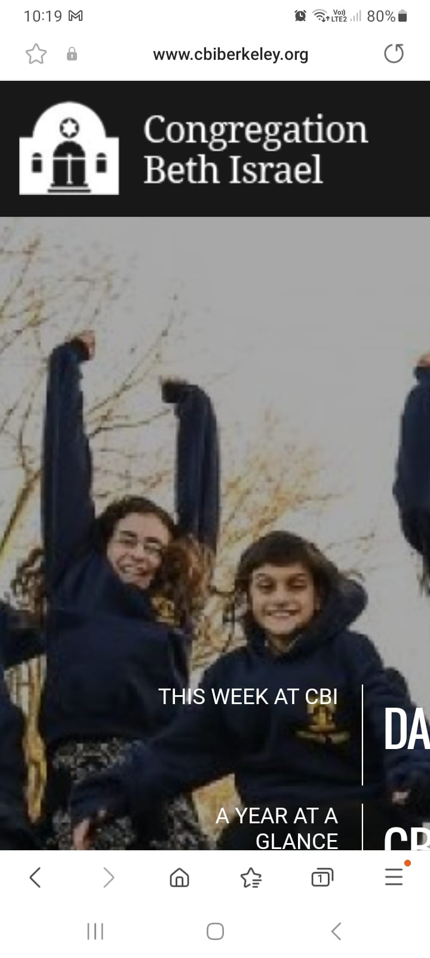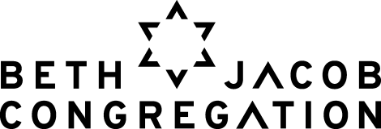

***Summer Mission to Israel***

Led by Rabbi Yonatan Cohen and Rabbi Gershon Albert

*July 29-August 4, 2024*

updated April 7

|  |  |
| --- | --- |
| **Monday, July 29:** |  |

* Check into your hotel from 3:00pm
* Rendez-vous in the hotel
* Meet a **political analyst** for an update on the situation in Israel today and prospects for the future
* Dinner, orientation and get to know each other

***Overnight:*** *City Hotel, Tel Aviv*

|  |  |
| --- | --- |
| **Tuesday, July 30:** |  |

* Volunteer for **Leket Israel** in their distribution center
* Encounter with the leaders of **Achim V’Achayot L’Yisrael**, the organization largely responsible for the quick and efficient support network to help Israelis in need from October 7th and onward
* Lunch on own in the Sarona Market
* Visit the grave of Rabbi Cohen’s nephew, Captain Yoav Malayav, who heroically fell defending Israel on October 7th
* **Bikur Cholim** – visit injured soldiers rehabbing from their injuries and pamper them with gifts
* Visit **Captives Square** to meet some of the family members and friends of captives held in Gaza (we hope we will not need to do so by then)
* Processing session
* Dinner on own

***Overnight:*** *City Hotel, Tel Aviv*

|  |  |
| --- | --- |
| **Wednesday, July 31:** |  |

* Early morning departure to the south
* Visit the grave of former OHDS student Captain Eyal Mevorach Twito z”l, who heroically fell in battle in Gaza in January
* **Bear witness** at one of the kibbutzim hit hard by the events of October 7th
* Packed lunch
* **Discussion and veggie picking** and tasting with farmer Uri Alon on the current situation and what needs to happen
* Pay your respects at the site of the **Re’im Supernova**
* Sponsor a **barbeque dinner for IDF soldiers** located in the area and join them to get to know them and hear their experiences
* Travel to Jerusalem and check into your hotel

***Overnight:*** *Cassia Hotel, Jerusalem*

|  |  |
| --- | --- |
| **Thursday, August 1:** |  |

* **Study session** with **Rabbi Judah Dardik**, former rabbi of Beth Jacob Congregation
* Pack food for Israel’s needy with **Pantry Packers**
* Obtain some tools for Israel Advocacy at the **Stand With Us Visitors Center**
* Meet with **Rabbi Benny Lau**, one of the leading figures in Israel’s modern Orthodox world
* Processing session

***Overnight:*** *Cassia Hotel, Jerusalem*

|  |  |
| --- | --- |
| **Friday, August 2:** |  |

* Meet with **Rabbi Dr. Leon Weiner Dow**, Director of the Kolot Beit Midrash, for a study session on the current situation
* Encounter with **Jessica Elter**, who lost her heroic boyfriend of six years on October 7th; hear the story of how she has become Shabbat observant ever since
* Support Israel at the **Machane Yehuda Shuk**
* Processing session
* Return to the hotel to prepare for Shabbat
* Join the scores of Israelis and Jews from around the world as they bring in **Shabbat at the Kotel**
* Shabbat dinner in the hotel with lone soldiers

***Overnight:*** *Cassia Hotel, Jerusalem*

|  |  |
| --- | --- |
| **Saturday, August 3:** |  |

Parshat Matot-Masei

* Daven in **VeAni Tefillah**; then meet with the shul rabbi – **Harav Aharon Leibowitz**, who grew up in CBI
* Shabbat lunch in the hotel
* **Study session** with Rabbis Albert and Cohen
* Optional walking tour of **Mishaknot Shaananim** and **Yemin Moshe**
* Musical Havdallah
* Free evening to support Israeli businesses

***Overnight:*** *Cassia Hotel, Jerusalem*

|  |  |
| --- | --- |
| **Sunday, August 4:** |  |

* Discussion with **Yossi Klein Halevi** at the Hartman Institute
* Encounter with **Soldiers Save Lives**, a group of 20-somethings who – after losing their friend on October 7th – got together to bring millions of dollars worth of supplies to soldiers
* Pay your respects to the soldiers who lost their lives over the last few months at the **Mt. Herzl National Military Cemetery**
* Final discussion
* Farewell dinner
* Transfer to the airport for your flight home
* Start planning your next trip to Israel
* Listed activities and speakers are subject to confirmation.
* Program will be staffed by a Keshet Israel Tour Educator.
* All breakfasts plus underlined meals are included in the package price.
* This itinerary is proprietary to Keshet and is intended for the promotion of and to inform those considering joining this Keshet trip. It is not to be transmitted to any other party without prior authorization from Keshet.

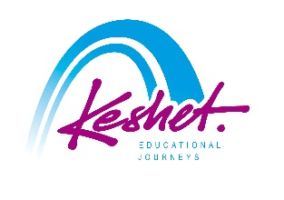

**Keshet Educational Journeys**

PO Box 52236 Jerusalem 9152102 Israel

Phone: 972-2-671-3518 | Fax: 972-2-671-3624

keshet@keshetisrael.co.il | www.keshetisrael.co.il