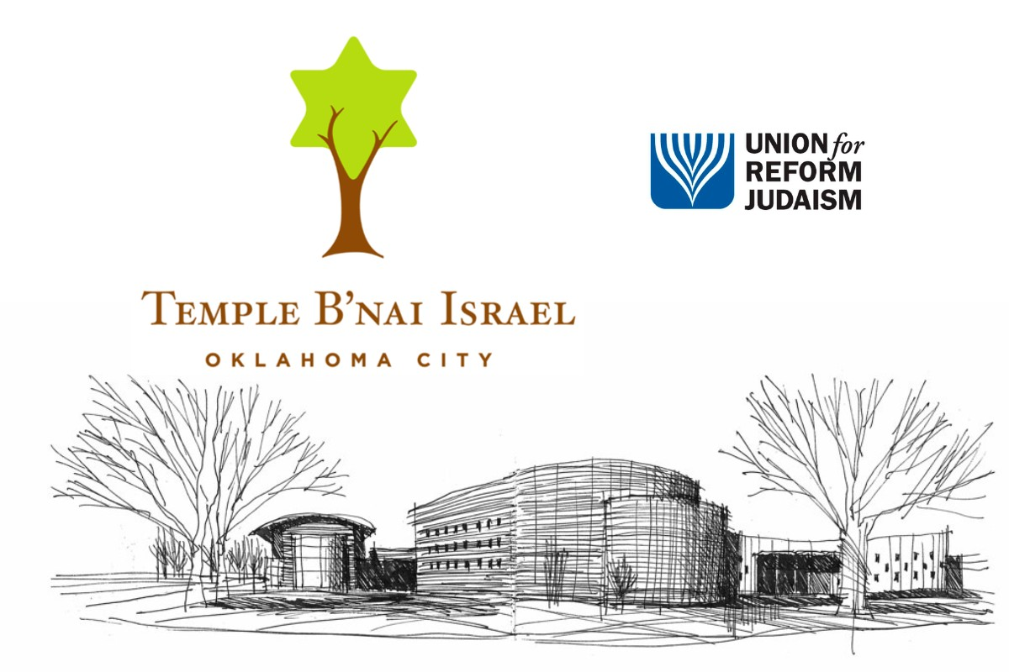

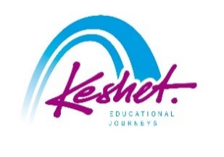

***Solidarity Mission to Israel***

***Led by Rabbi Vered Harris***

*November 7-14, 2024*

updated May 12

|  |  |
| --- | --- |
| **Thursday, November 7:** | ***bruchim Habaim – welcome to Israel!*** |

* Arrival in Israel
* **Meet and Greet Service** will greet you after passport control and take you through baggage claim and customs and over to your awaiting guide
* Load the bus and travel to Jerusalem; check into the hotel
* Welcome dinner and orientation in a local restaurant

**Overnight:** *Arthur Hotel*, *Jerusalem*

|  |  |
| --- | --- |
| **Friday, November 8:** | ***This year in jerusalem!*** |

Not sure a volunteer opportunity would be available on a Friday, in which case:

* Meet with **Rabbi Dr. Leon Weiner Dow**, Director of the Kolot Beit Midrash and a former Hartman fellow – for a study session
* Support Israel and purchase edible treats to be given out next week at the vibrant **Machane Yehuda Shuk**
* Return to the hotel and prepare for Shabbat
* In the evening, participate in a community **Shabbat service** at the progressive synagogue in Shoham, followed by a communal dinner there

***Overnight:*** *Arthur Hotel*, *Jerusalem*

|  |  |
| --- | --- |
| **Saturday, November 9:** |  |

* Free morning in Jerusalem; you may want to:
  + Attend a local synagogue
  + See the Dead Sea Scrolls and other gems at the Israel Museum
  + Wander around the Arab Souq
  + Visit the trendy First Train Station
* Lunch on your own
* Optional walking tour of **Mishaknot Shaananim** and Yemin Moshe
* Musical Havdallah
* Free evening to support Israeli businesses

***Overnight:*** *Arthur Hotel, Jerusalem*

|  |  |
| --- | --- |
| **Sunday, November 10:** | ***otef aza (Gaza envelope)*** |

* Early morning departure to the south
* **Agricultural work** on a farm in the Gaza perimeter
* Pay your respects at the site of the **Reim Supernova**
* **Encounter with soldiers** located in the area and treat them to a **BBQ dinner**
* Return to Jerusalem
* Processing session

**Overnight:** *Arthur Hotel, Jerusalem*

|  |  |
| --- | --- |
| **Monday, November 11:** | ***helping hand*** |

* Work in the **Meir Panim Soup Kitchen**
* At the **Stand With Us Visitors Center**, obtain the tools for Israel advocacy
* Discussion session with Palestinian **Issam Saad**, a former Gazan who has been on the Hamas’s Most Wanted list after starting an Israeli-Palestinian dialogue camp for Israeli and Palestinian youth

***Overnight:*** *Arthur Hotel, Jerusalem*

|  |  |
| --- | --- |
| **Tuesday, November 12:** | ***back to the border*** |

* Visit to **Segev Shalom** to meet with Amal, an inspirational Bedouin woman who has taken it upon herself to help with much of the 200,000 strong Bedouin community of the Negev during this difficult time; work with her in packing foods and other essentials for Israel’s Bedouin community
* Visit to **Ofakim**, the city invaded by Hamas on October 7th and work with the needy of the community there

OR

Participate in **agricultural volunteering** in the area

* Return to Jerusalem and dinner on your own

***Overnight:*** *Arthur Hotel, Jerusalem*

|  |  |
| --- | --- |
| **Wednesday, November 13:** | ***if i forget thee, oh tel aviv*** |

* Volunteer at the **Leket Distribution Center** – which rescues food from hotels, restaurants and celebration halls and gives it to the needy
* Encounter with **HIAS** for a discussion and volunteer session with African refugees in Tel Aviv
* Lunch on your own in the trendy **Sarona Foodie Market**
* Visit to **Hostage Square** in order to recall the freed hostages whom were held by Hamas from October 7th; this area – outside the Tel Aviv Museum of Art – is to be kept as a permanent site to remember the plight of the hostages
* Meet with a **political analyst** for an update on what has happened in Israel of the last year and a glimpse into the future
* Return to Jerusalem and dinner on your own

***Overnight:*** *Arthur Hotel, Jerusalem*

|  |  |
| --- | --- |
| **Thursday, November 14:** | ***all eyes on jerusalem*** |

* Put together medical supplies with **Yad Ezer**
* Tour of the **Mt. Herzl National Military Cemetery**, including the new graves
* At the **ANU Museum of the Jewish People**, see how the Jewish People spread around the world and their contributions to it
* Summary discussion
* Farewell Dinner
* Transfer to the airport for your flight home
* Start planning your next trip to Israel!

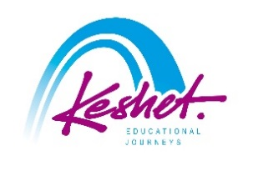

**Keshet Educational Journeys**

PO Box 52236 Jerusalem 9152102 Israel

Phone: 972-2-671-3518 | Fax: 972-2-671-3624

keshet@keshetisrael.co.il | www.keshetisrael.co.il