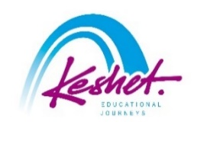

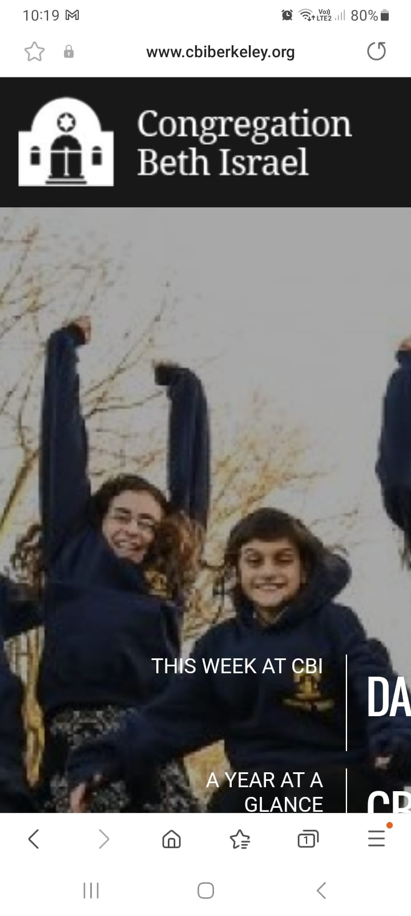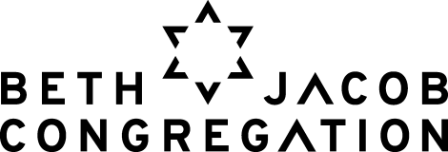

***Family Mission to Israel***

Led by Rabbi Yonatan Cohen and Rabbi Gershon Albert

*July 29-August 4, 2024*

updated April 7

|  |  |
| --- | --- |
| **Monday, July 29:** | ***Bruchim HaBaim – welcome to Israel*** |

* Check into your hotel from 3:00pm
* Rendez-vous in the hotel
* Meet a **political analyst** for an update on the situation in Israel today and prospects for the future (ice-breakers and games for kids)
* Dinner, orientation and get to know each other

***Overnight:*** *City Hotel, Tel Aviv*

|  |  |
| --- | --- |
| **Tuesday, July 30:** | ***on the ground, underground*** |

* Volunteer for **Leket Israel** in their distribution center in Raanana
* Enter the subterranean munitions factory where Jews produced bullets literally under the noses of the ruling British leading up to the War of Independence at the **Ayalon Institute**
* Peruse the crafts, meet the artisans and enjoy the street performers at the renowned **Nahalat Binyamin Arts and Crafts Fair** and have lunch at the adjacent **Carmel Market**
* Lunch on own
* At the newly open, interactive **ANU Museum**, hear how the Jewish People spread throughout the world and their contributions to it
* Visit **Captives Square** to meet some of the family members and friends of captives held in Gaza (we hope we will not need to do so by then) – parallel programing for youth
* Dinner on own

***Overnight:*** *City Hotel, Tel Aviv*

|  |  |
| --- | --- |
| **Wednesday, July 31:** | ***in the beginning*** |

* **Agricultural work** with **Leket Israel** in Rishon LeTzion
* Learn about the Armored Corps of the IDF and see the most advanced tanks in the world at the **Latrun Armored Corps Memorial**
* Packed lunch
* Participate in an **actual archaeological dig** at the Beit Guvrin National Park
* Sponsor a **barbeque dinner for IDF soldiers** located in the area and join them to get to know them and hear their experiences
* Travel to Jerusalem and check into your hotel

***Overnight:*** *Cassia Hotel, Jerusalem*

|  |  |
| --- | --- |
| **Thursday, August 1:** | ***This year in Jerusalem!!*** |

* **Study session** with **Rabbi Judah Dardik**, former rabbi of Beth Jacob Congregation – parallel programming for youth
* Pack food for Israel’s needy with **Pantry Packers**
* Obtain some tools for Israel Advocacy at the **Stand With Us Visitors Center**
* Meet with **Rabbi Benny Lau**, one of the leading figures in Israel’s modern Orthodox world – parallel programming for youth
* Processing session

***Overnight:*** *Cassia Hotel, Jerusalem*

|  |  |
| --- | --- |
| **Friday, August 2:** | ***In the land of our forefathers/mothers*** |

* Begin our exploration of the Jewish “love affair” with Jerusalem from the **Haas Promenade** with its magnificent views and powerful Biblical, historical and contemporary narratives
* Enter the **City of David** (the original Jerusalem of King David and First Temple times) for a guided visit with Bible in hand; then descend Warren's shaft a slosh through the water tunnel that King Hezakiya dug to save Jerusalem from the Assyrians 2,700 years ago
* Support Israel at the **Machane Yehuda Shuk**
* Return to the hotel to prepare for Shabbat
* Join the scores of Israelis and Jews from around the world as they bring in **Shabbat at the Kotel**
* Shabbat dinner in the hotel with lone soldiers

***Overnight:*** *Cassia Hotel, Jerusalem*

|  |  |
| --- | --- |
| **Saturday, August 3:** | ***shabbat shalom*** |

Parshat Matot-Masei

* Daven in **VeAni Tefillah**; then meet with the shul rabbi – **Harav Aharon Leibowitz**, who grew up in CBI
* Shabbat lunch in the hotel
* **Study session** with Rabbis Albert and Cohen
* Optional walking tour of **Mishaknot Shaananim** and **Yemin Moshe**
* Musical Havdallah
* Free evening to support Israeli businesses

***Overnight:*** *Cassia Hotel, Jerusalem*

|  |  |
| --- | --- |
| **Sunday, August 4:** | ***all eyes on jerusalem*** |

* Adults: Discussion with **Yossi Klein Halevi** at the Hartman Institute

Kids: Review the history of Israel at the newly renovated **Tower of David Museum**

* Everyone: See just how incredible King Herod’s Temple project must have been at the **Western Wall Tunnels**
* Pay your respects to the soldiers who lost their lives over the last few months at the **Mt. Herzl National Military Cemetery** (parallel programing for kids at the **Bloomfield Science Museum**)
* Final discussion
* Farewell dinner
* Transfer to the airport for your flight home
* Start planning your next trip to Israel
* Listed activities and speakers are subject to confirmation.
* Program will be staffed by a Keshet Israel Tour Educator and a youth guide for age-appropriate learning.
* All breakfasts plus underlined meals are included in the package price.
* This itinerary is proprietary to Keshet and is intended for the promotion of and to inform those considering joining this Keshet trip. It is not to be transmitted to any other party without prior authorization from Keshet.

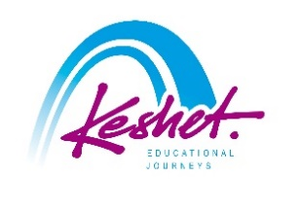

**Keshet Educational Journeys**

PO Box 52236 Jerusalem 9152102 Israel

Phone: 972-2-671-3518 | Fax: 972-2-671-3624

keshet@keshetisrael.co.il | www.keshetisrael.co.il