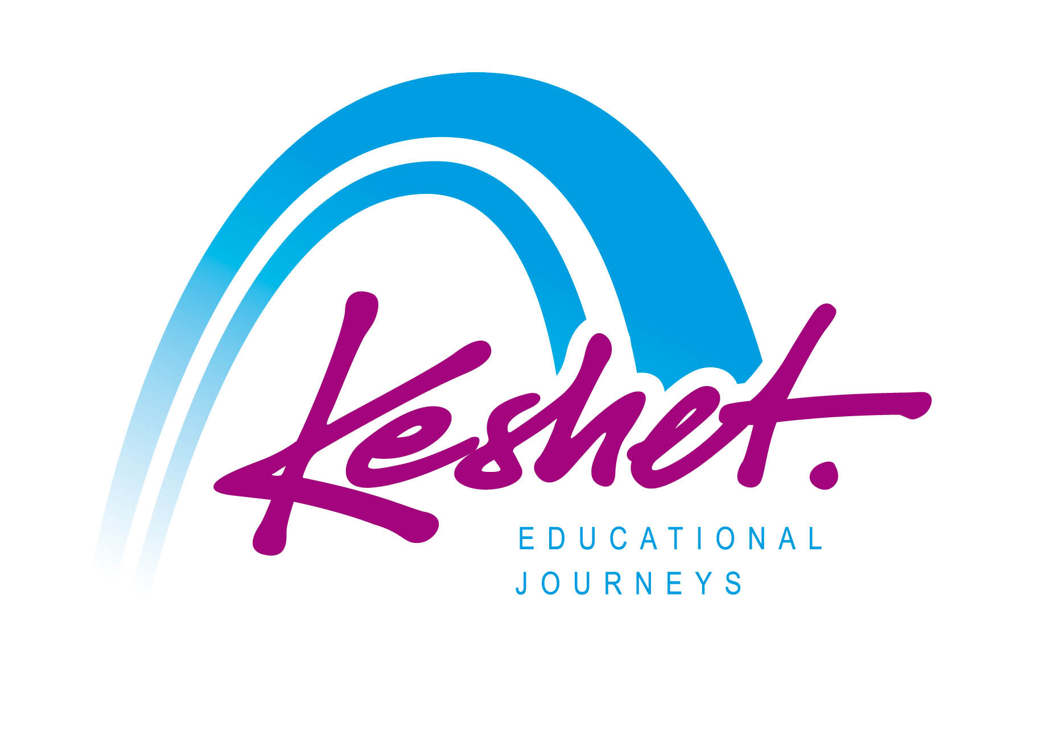

**Jewish Heritage Journey to Poland**

September 1 – 9, 2024

***FAQ***

**Q**: **Is this a Holocaust trip?**

**A:** The focus of the itinerary is the 1,000 year story of Jewish life in Poland, past and present. We will get to know the Jewish “world that was” and meet members and leaders of today’s Polish Jewish community. The itinerary also includes visits to Polish heritage sites including the Wawel Castle in Krakow and Old Town in Warsaw. While the fate of the Jews of Poland during the Shoah (Holocaust) looms large, it is not the sole focus of the trip

**Q**: **Is this a Jewish themed trip?**

**A:** Yes. We will be exploring Poland through the lens of the Jewish experience. It is however is open to all: Jews and non-Jews.

**Q**: **When and where does the tour begin and end?**

**A:** The touring program will begin Sunday evening September 1 in Warsaw and will end on Monday midday September 9 in Warsaw

**Q**: **What about flight arrangements?**

**A:** Each trip participant will be making their own flight arrangements to arrive in Warsaw by Sunday afternoon September 1(or earlier) and to depart from Warsaw on Monday afternoon September 9 (or later). If you need advice regarding flights, please contact Keshet Educational Director Daniel Ehrlich at danny@keshetisrael.co.il

**Q**: **How about transportation from Warsaw’s Chopin Airport at the beginning of the trip and to Warsaw Chopin Airport at the conclusion of the trip?**

**A:** The trip price does not include transportation from Warsaw Airport. The Keshet staff will be happy to arrange a pre-reserved, pre-paid airport transfer for you. On Monday midday September 9, there will be one group bus transfer to Warsaw Chopin Airport at the conclusion of the trip program timed to the flight departure times of most of the group.

**Q**: **Can additional touring and/or family roots explorations in Poland be arranged before the start of or after the end of the group trip itinerary?**

**A:** Absolutely. We can help you plan additional touring and/or family roots explorations in Poland before or after the trip. Please be in touch with Keshet Tour Educator Daniel Ehrlich [danny@keshetisrael.co.il](mailto:danny@keshetisrael.co.il)

**Q**: **Can special dietary needs such as gluten free, vegetarian/vegan, kosher, allergies/food sensitivities etc be accommodated?**

**A:** Yes – absolutely. Keshet has a lot of experience in this area. The trip price includes regular breakfasts at each hotel which generally includes fruits, vegetables, fish, cereals, cheeses, yoghurts, eggs etc. All provided lunches and dinners will be kosher. For meals are “on your own” our Polish guides and hotel staff will assist you in finding the best places to eat. There are kosher eateries in Krakow and Warsaw as well as vegetarian and vegan restaurant options in Krakow, Lublin and Warsaw.

**Q**: **Can Sabbath observance be accommodated on the trip?**

**A:** Yes - absolutely. The Holiday Inn City Center is just a few minutes’ walk from Krakow Old Town Square, Wawel Castle and other sites in central Krakow including the Kazimierz Old Jewish Quarter where we will be having Kosher Friday night dinner with the local Jewish community. (A kosher Shabbat lunch can be preordered and prepaid as well).Synagogue services are also within easy walking distance of the hotel.

**Q**: **Who will be leading and guiding the trip?**

**A:** Keshet’s Educational Director Danny Ehrlich will be the main tour educator. Danny has been organizing and guiding Jewish Heritage Trips to Poland for 20 years and is one of the most experienced and dynamic guides in the field. He will be joined by a local Polish guide and by specialty guides at various museums and sites.

**Q**: **How can I register for the trip?**

**A:** In order to reserve your place on the trip please complete the initial registration form (without financial commitment) by **May 22,2024**

[**https://KeshetIsrael.formstack.com/forms/keshet_s_jewish_heritage_tour_to_poland_2024_registration_form**](https://keshetisrael.formstack.com/forms/keshet_s_jewish_heritage_tour_to_poland_2024_registration_form)

**Q**: **When will we know if there are enough people registered for the trip to take place as advertised?**

**A:** The first trip payment of $1,000 per person is due by **June 3, 2024**. Invoices will be sent to all who have registered - if enough people have registered by then.

For full itinerary and pricing information click here: <https://www.keshetisrael.co.il/herpol>

Registration link:

[**https://KeshetIsrael.formstack.com/forms/keshet_s_jewish_heritage_tour_to_poland_2024_registration_form**](https://keshetisrael.formstack.com/forms/keshet_s_jewish_heritage_tour_to_poland_2024_registration_form)

Please feel free to contact us with any questions [danny@keshetisrael.co.il](mailto:danny@keshetisrael.co.il)